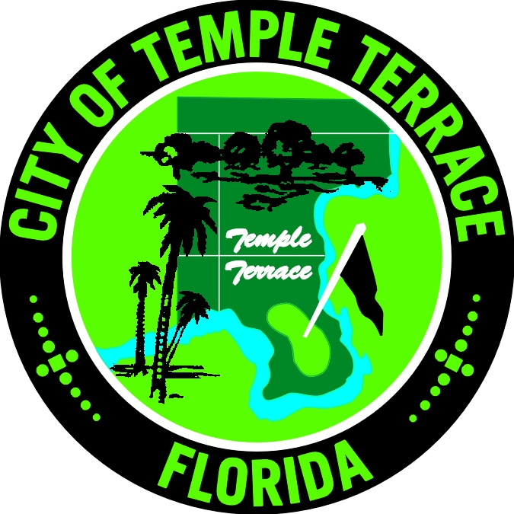

CITY OF TEMPLE TERRACE
NEWS RELEASE

April 20, 2005

FOR MORE INFORMATION, CONTACT:
Paula MacDonald, Public Information Officer @ (813) 477-7218

FOR IMMEDIATE RELEASE

TEMPLE TERRACE RECOGNIZES BUILDING SAFETY WEEK
(TEMPLE TERRACE, FL – 4/20/05) During the week of May 8-14, the City of Temple Terrace Community Services department will recognize National Building Safety Week to promote the importance of safe construction and fire safety codes to protect life and property.

As an active member of the International Code Council, the City of Temple Terrace abides by a standard of codes used to construct residential and commercial structures. Codes address all aspects of construction, including structural integrity, electrical, mechanical, plumbing systems, and property maintenance. By inspecting a structure during and after construction, building department professionals and fire safety officials ensure that buildings in our city are safe places to live, work, and play.

“Building and fire officials are here to help the public understand building safety issues,” explains Charles Stephenson, Building Official. “In this age of do-it-yourselfers, it becomes extremely important for homeowners to work with the City to make sure their residence fully complies with building safety codes.”

As part of Building Safety Week, free home safety inspections will be offered to City residents by certified building inspectors throughout the month of May. In addition, an informational session for realtors and individuals interested in the permitting and inspection processes will be held on Tuesday, May 10, from 10:00 a.m. - 12:00 p.m. This event will take place in the Council Chambers at City Hall, 11250 N. 56th Street.

The importance of regulating and enforcing building codes is, unfortunately, often overlooked until a catastrophic tragedy occurs. With over 5,000 building inspections in 2004, the City of Temple Terrace Community Services department is working diligently to ensure the safety of structures in our community. In addition, the Fire Department and Community Services also enforce property maintenance regulations, review building plans, and issue building permits.

To learn more about the free home safety inspection or to register the informational session on May 10, please call the City of Temple Terrace Community Services department at (813) 989-7020.

###

